c NEPAL COLLEGE OF INFORMATION TECHNOLOGY

UNIT-TEST

SUBJECT-PROBLEM SOLVING TECHNIQUE

***1.*** Of all parallelograms with a given perimeter, which has the greatest area?

**2**. Suppose that we are given a triangle with base QR. Give a constructive method for drawing a segment parallel to QR, terminating on the sides PQ and PR of the triangle, that divide the area of triangle into two equal halves.

**3**. Assume that P is a regular polygon with k sides. What is the measure of any of the K angles formed by P?

**4**. Prove the Pythagorean Theorem.

**5**. Prove cosine law.

6. Suppose that ABC is a triangle in the plane. Let P, Q and R be the mid-points of each of the three sides. Prove that the triangle formed by P, Q and R is similar to the given triangle ABC.

**7**. True or FALSE: If the diagonals of a parallelogram are perpendicular then the parallelogram is a rectangle.

**8**. The perimeter of certain Right angled triangle is 60 inches. The height perpendicular to the hypotenuse is 12 inches. What are the length of the three sides of the triangle?

9. Show that the diagonals of a quadrilateral are perpendicular if and only if the sum of square of one pair of opposite sides of the quadrilateral equal to the sum of the square of the other pair of opposite sides.

**10**. Look at the two angles in figure below with squares, show that the sum of these angles is 450.

|  |  |  |
| --- | --- | --- |
|  |  |  |

11. Show that if two medians of a triangle are equal then the triangle is isosceles.

**12**. Consider a polyhedron with five triangular face meeting at each vertex. How many faces will it have?

13. Explain why it is impossible to have a polyhedron with 6 triangular faces meeting at each vertex.

14. A circle of radius 10 is inscribed in an equilateral triangle of suitable size. Then three more circles are inscribed between first circle and two sides of the triangle near each vertex. The process continuous indefinitely, with progressively smaller circles. What is the sum of the radii of all the circles?

15. Prove that any angle subtended by semi –circle is right angle.

16. A right angled triangle has side length l, m and 10.Note that 10 is not hypotenuse, and I and m are both positive integers .Find the value of I and m.

**17**. The length of the sides of a triangle form a sequence of positive integers: n, n+1, n+2. The area of the triangle is 6.Finf the sides and angles of the triangle.

18. A right circular cone, as shown on figure, has a cube inscribed in it with length of the side is d. If the radius of the cone is 2, and its height is 6, then what is the volume of the cube?

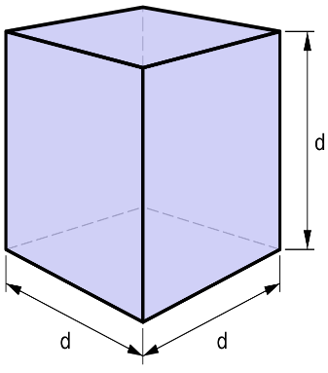

19.Consider a unit cube with four of its eight vertices joined to form a regular tetrahedron with vertices A,B,C,D (in figure).What is the ratio of the surface area of the cube to the surface area of the tetrahedron? Also find the ratio of volume of tetrahedron to the volume of the box?

20. Express the area of a triangle with a formula using only the triangles three sides.